**Final Report of Xenon**

**By**

**Xenamorphs**

**Project Overview**

A user-friendly, simple web-based game that aids chemistry students in their learning of molecular nomenclature.

**Features Implemented**

The Xenamorph additions to Xenon were as follows:

* Missing level 3 was created.
* Level selection screen was implemented with allows users to skip levels.
* Testing framework was established with Nightwatch.
* Level 1 code was cleaned and lines of code condensed by over fifty percent.

**What’s Left**

* Master level
* Database needs to be connected to the leaderboard
* Testing all code.
* Cleaning levels 2, 4 and 5 (if desired)

**Known Issues**

None at this time.

**Functionality**

**HomeScreen**

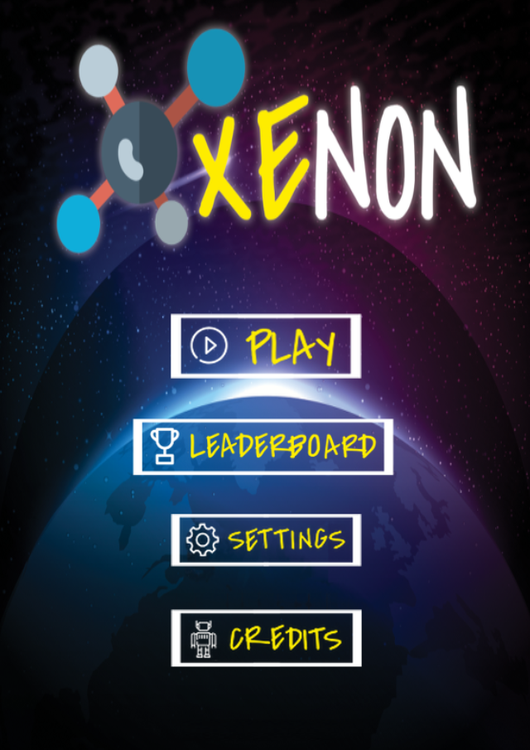

**Level 1**

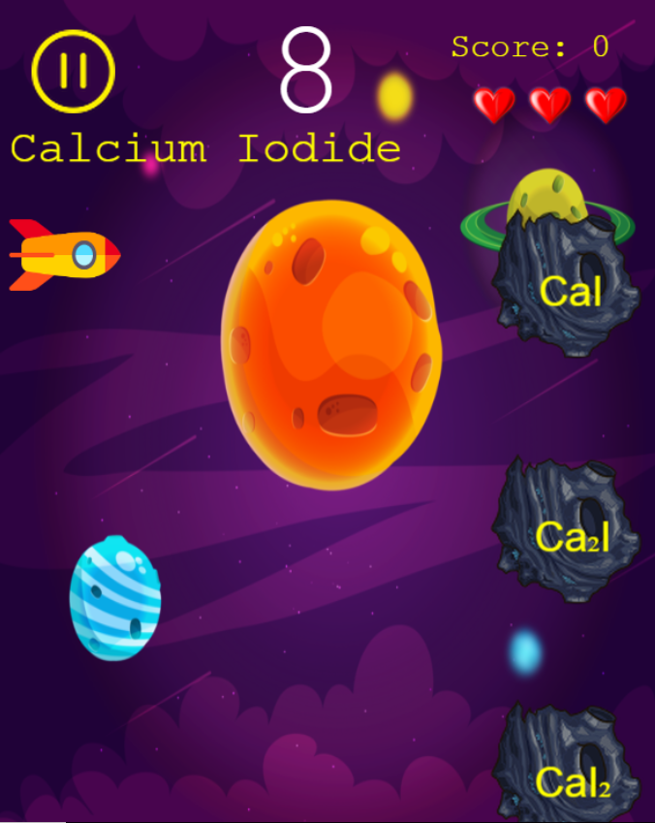

**Level 2**

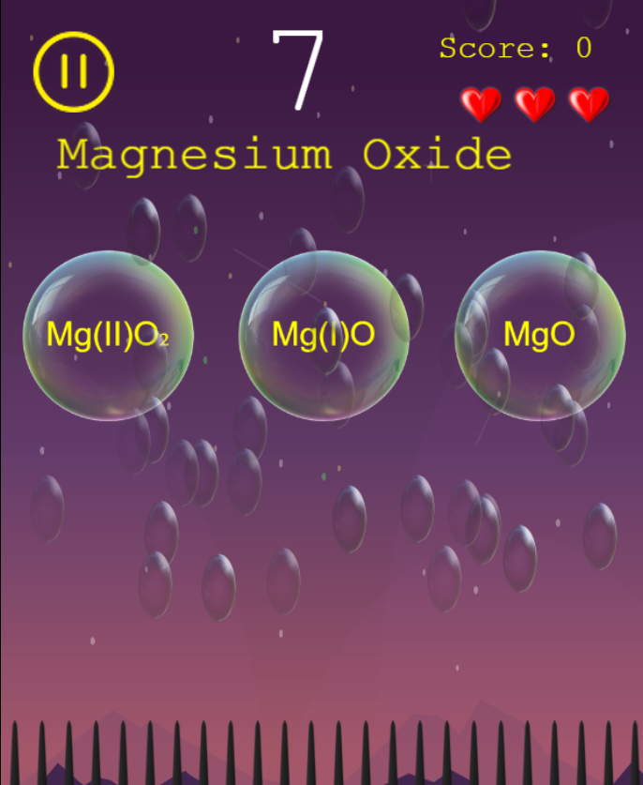

**Level 3**

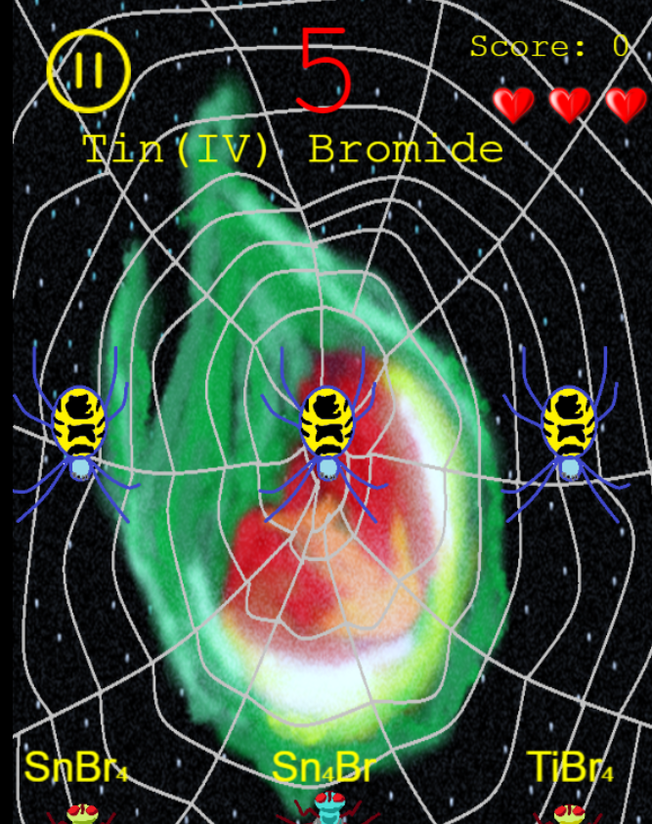

**Level 4**

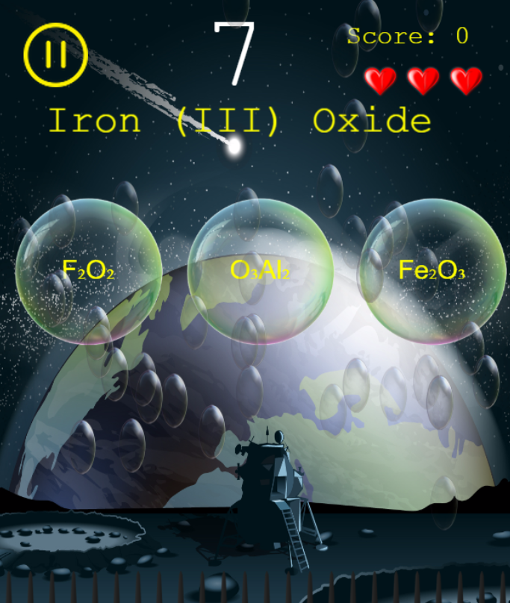

**Level 5**

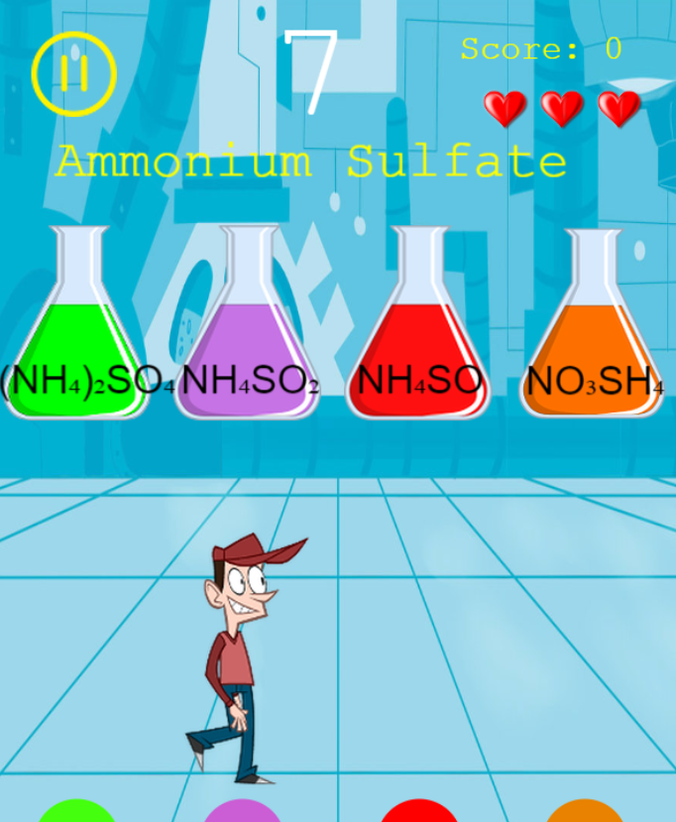

**Level Selection Screen**

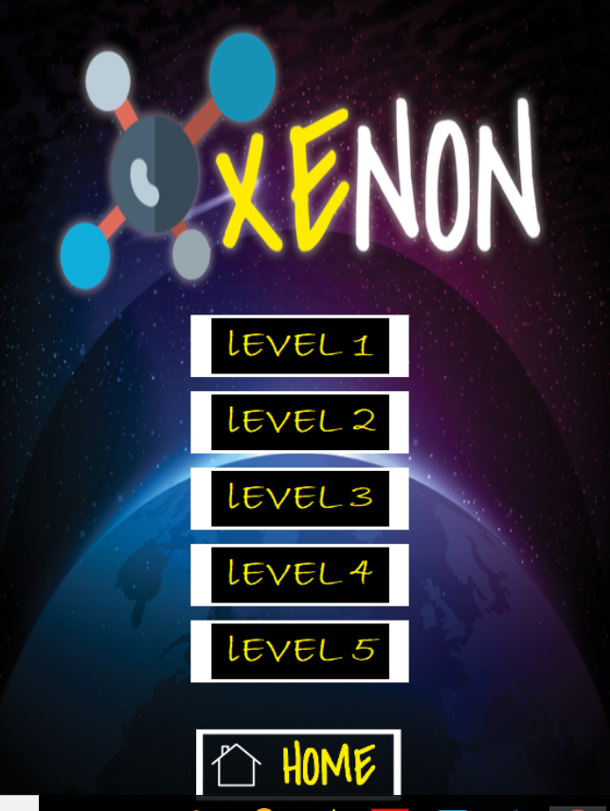

**GAME POSTER**

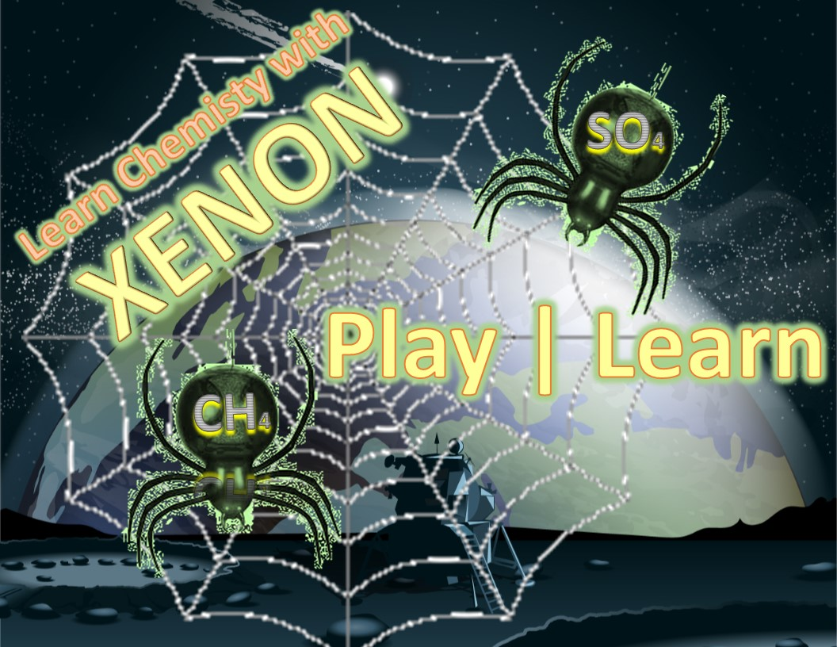

**Screencast**

You can view the screencast at this link <https://youtu.be/7Zr2xxn9mUw>

**The Team**

**Development Team:**

**Laura Arevalo –** Laura graduates in May 2018 and is an Information Technology major with a concentration in Software Development. She is interested in full-stack web development and data analytics. She server as project lead and documentation manager for Xenon.

**Cat Windham -** Caitlin, "Cat" for short, is an ITEC major with a concentration in Software Development. Her expected graduation date is May of 2018. She is interested in augmented and virtual reality and hopes to get a career in this field.

**Charneaka Lewis -** Charneaka is originally from Bessemer, AL.  She is an IT/Software Development major in her senior year and is scheduled to graduate in December of 2018. She loves music, cooking, reading, and movies.  Her plan for the future is to obtain a job focusing on obtaining databases or as a java developer.

**Magdalena Ledezma-**

**Chinelo Obiamalu –** Chinelo, Chin-Chin for short, is an Information Technology major with a concentration in Software Development. Her graduation date is May 2018, and she is interested in UI/UX design, Artificial intelligence and Augmented reality and hopes to get a job within one of these fields. She served as the UI/UX designer for Xenon.

**A group of people posing for the camera

Description generated with very high confidence**

**Clients:**

**Ceniz Gunay**

|  |  |
| --- | --- |
| **A person wearing a white shirt and smiling at the camera  Description generated with very high confidence** | * **GGC Assistant Professor in Information Technology** * **Dr. Cengiz Gunay is a self-taught computer programmer** * **Bachelor's degree with an electronics and telecommunications focus** * **Switched to computer science and specialized in artificial intelligence and neural networks** |

**Thomas Gluick**

|  |  |
| --- | --- |
| **A person wearing glasses and smiling at the camera  Description generated with very high confidence** | * **GGC assistant professor of Chemistry** * **Dr. Gluick began at the University of Texas as an assistant professor.** * **Rresearch chemist at the Smithsonean Institute** * **Taught Biochemistry at the University of Maryland** * **Genetic Biologist at the National Institute of Health** |

**Testing**

**Coverage**

**Methods**

**Results**

**Usability Testing**

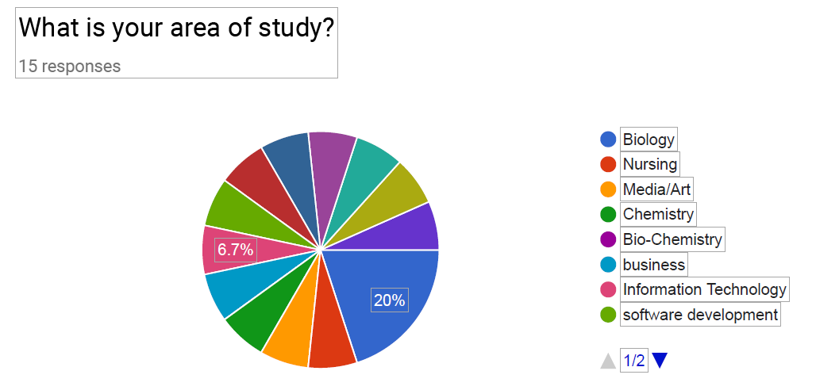

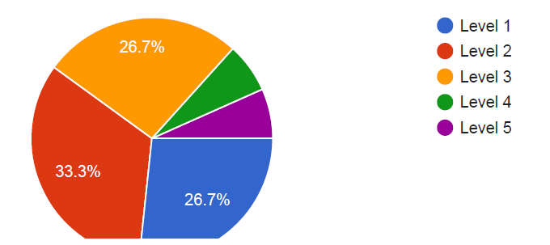

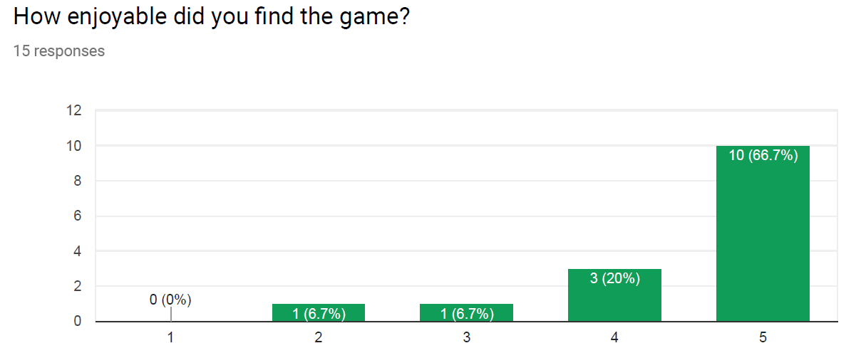  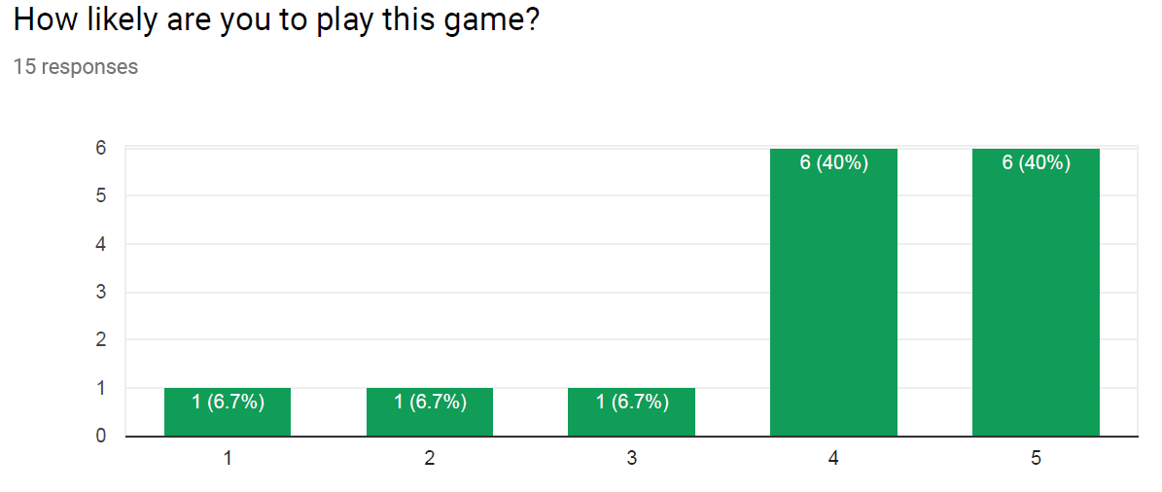 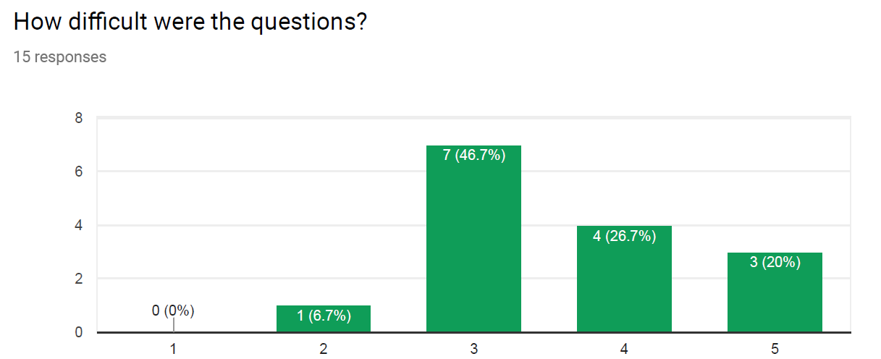

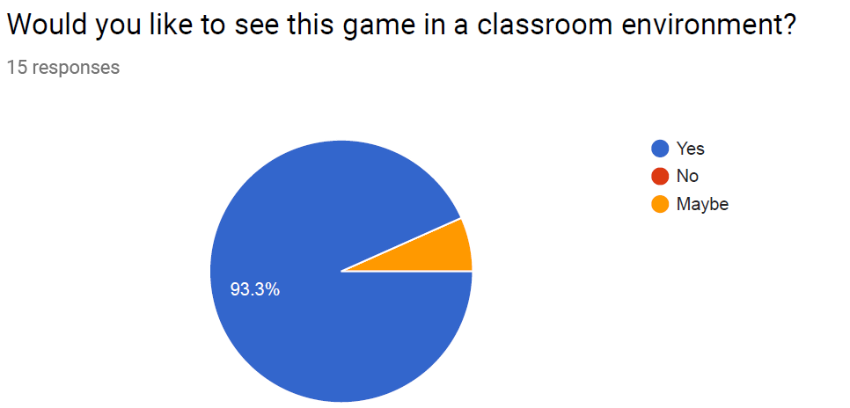



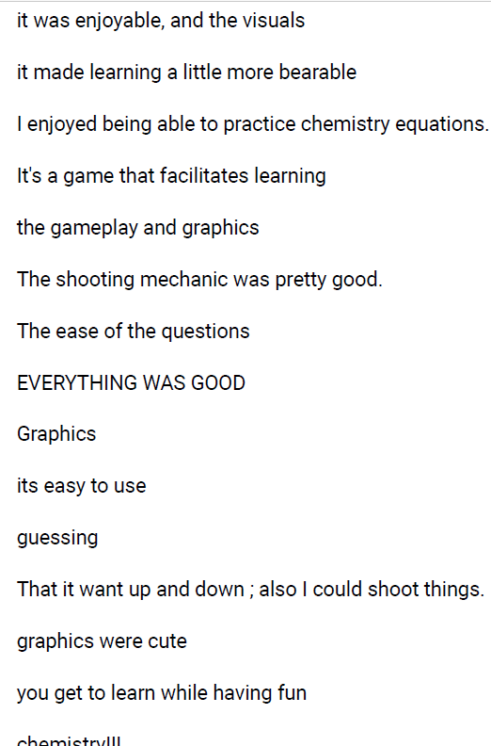  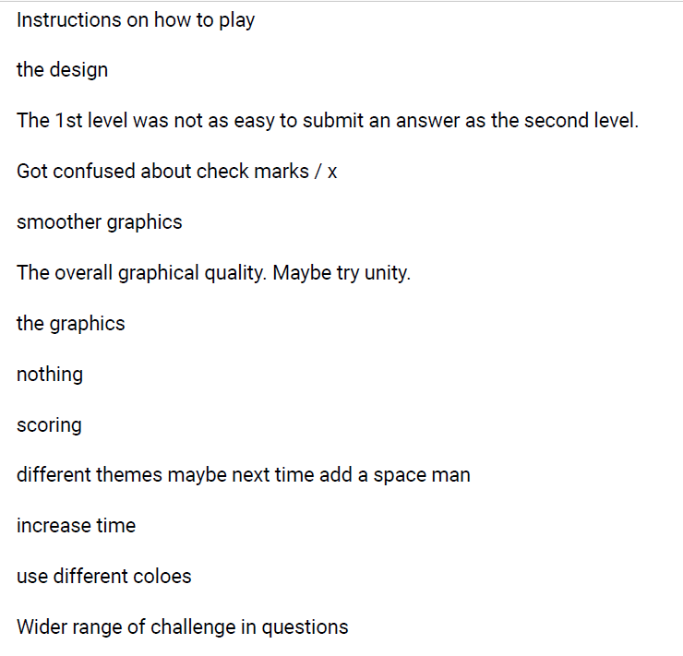 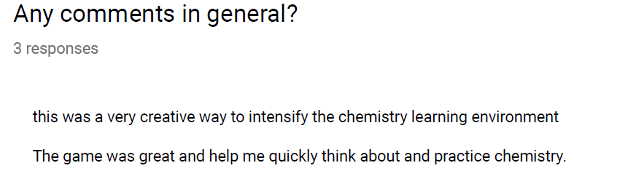

**Instructions**

**Installation**

* No installation required. Simply visit <https://soft-eng-practicum.github.io/xenon/>

**Developer and User Documentation**

* All documentation can be found in the Xenon Github repository at

<https://github.com/soft-eng-practicum/xenon/tree/master/official-documentation>

**Licensing**

* Licensing is under the Creative Commons Attribution-Non-Commercial 4.0 International and can be viewed at